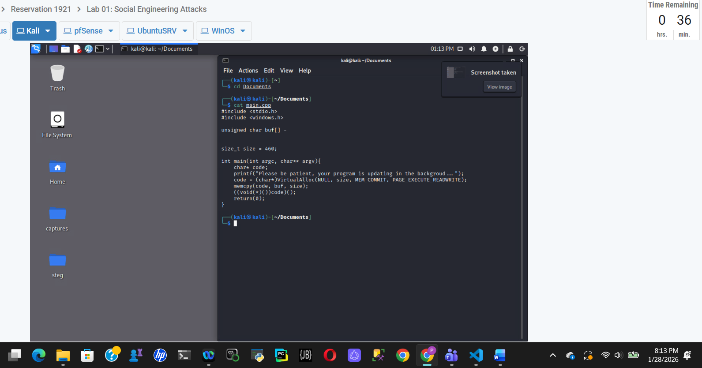
Screenshot 1: Editing Payload Source Code in Kali Linux
This screenshot shows the Kali Linux environment with the Nano text editor open. A C++ source file is being edited to include a malicious payload stored in a character buffer. This step prepares the payload to be compiled into an executable, demonstrating how attackers embed malicious code into a program as part of a social engineering attack.

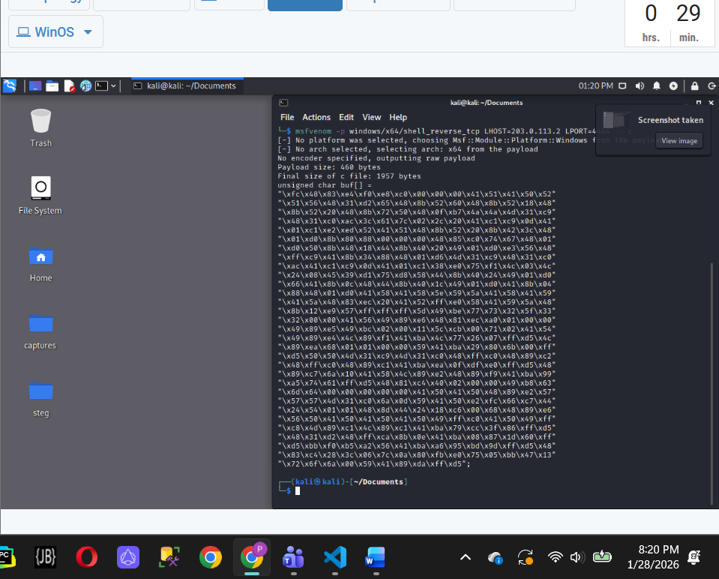
Screenshot 2: Generating Shellcode with MSFVenom in Kali Linux
This screenshot shows the Kali Linux terminal running the msfvenom command to generate shellcode for a reverse TCP payload. The output displays the encoded shellcode that will be embedded into the main.cpp source file. This step demonstrates how attackers create payloads that can establish a remote connection back to the attacker’s system

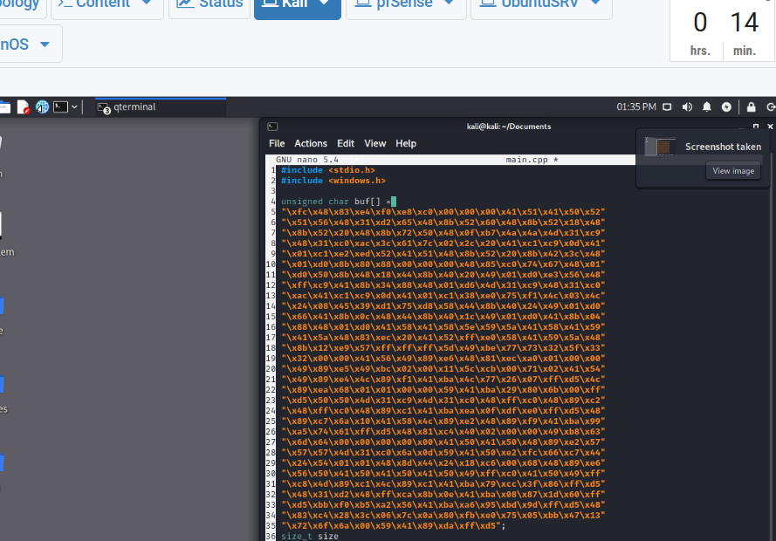
Screenshot 3: Inserting Generated Shellcode into main.cpp
This screenshot shows the Nano text editor in Kali Linux with the main.cpp file open. The shellcode generated using msfvenom is pasted into the character buffer within the C++ source code. This step completes the process of embedding the payload into the program before compiling it into an executable.
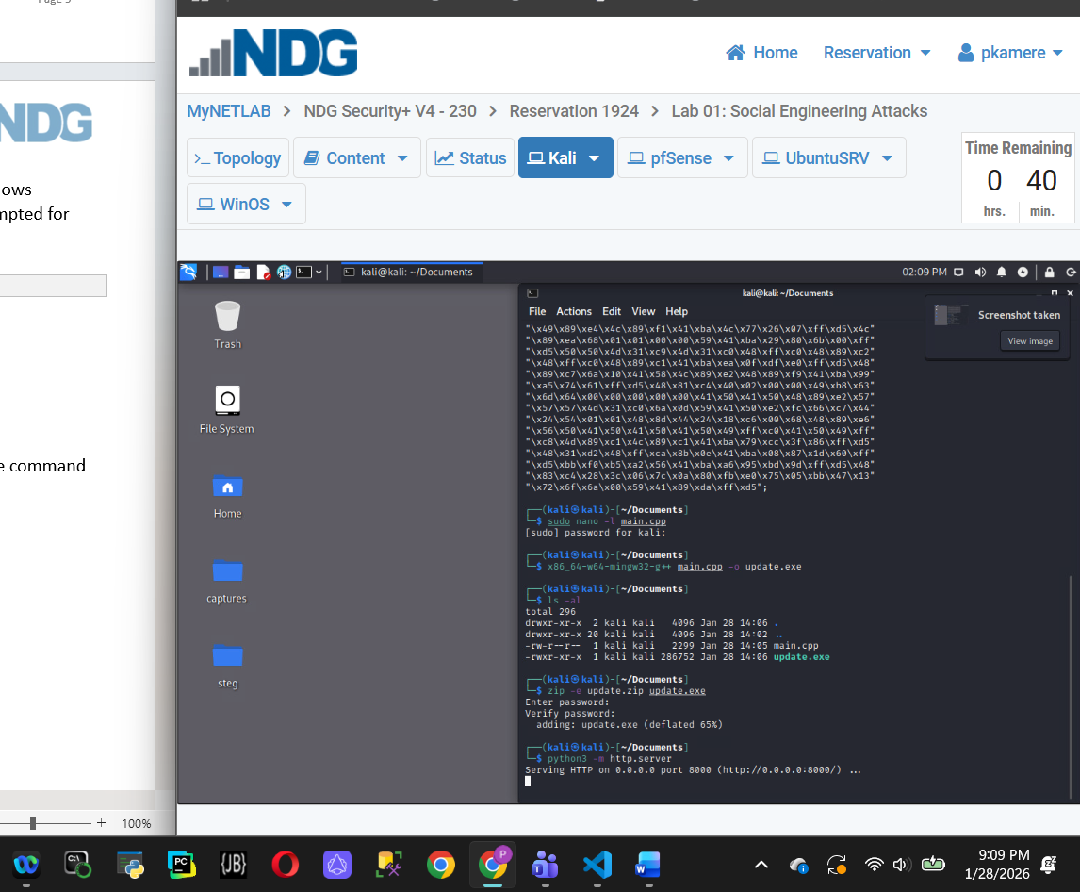
Screenshot 4: Compiling main.cpp and Hosting the Executable
This screenshot shows the Kali Linux terminal compiling the main.cpp file using the g++ compiler to create an executable. After compilation, a simple HTTP server is started to host the executable file. This allows the program to be downloaded by the target system as part of the social engineering attack scenario.
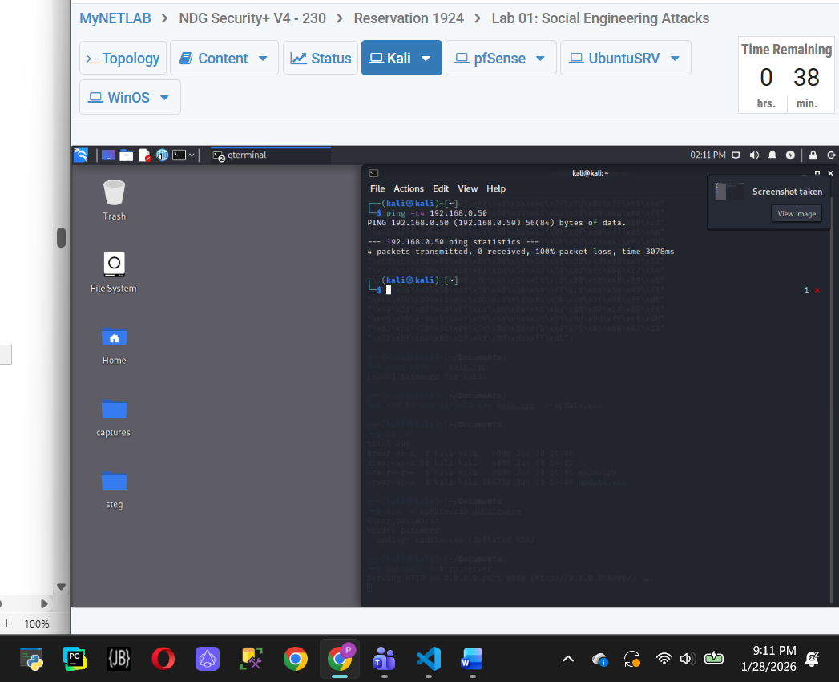
Screenshot 5: Network Connectivity Test Showing No Response
This screenshot shows the Kali Linux terminal using the ping command to test network connectivity. No response packets are received, indicating that the target system is not reachable at this stage. This result highlights the need for proper network configuration before a reverse connection can occur.
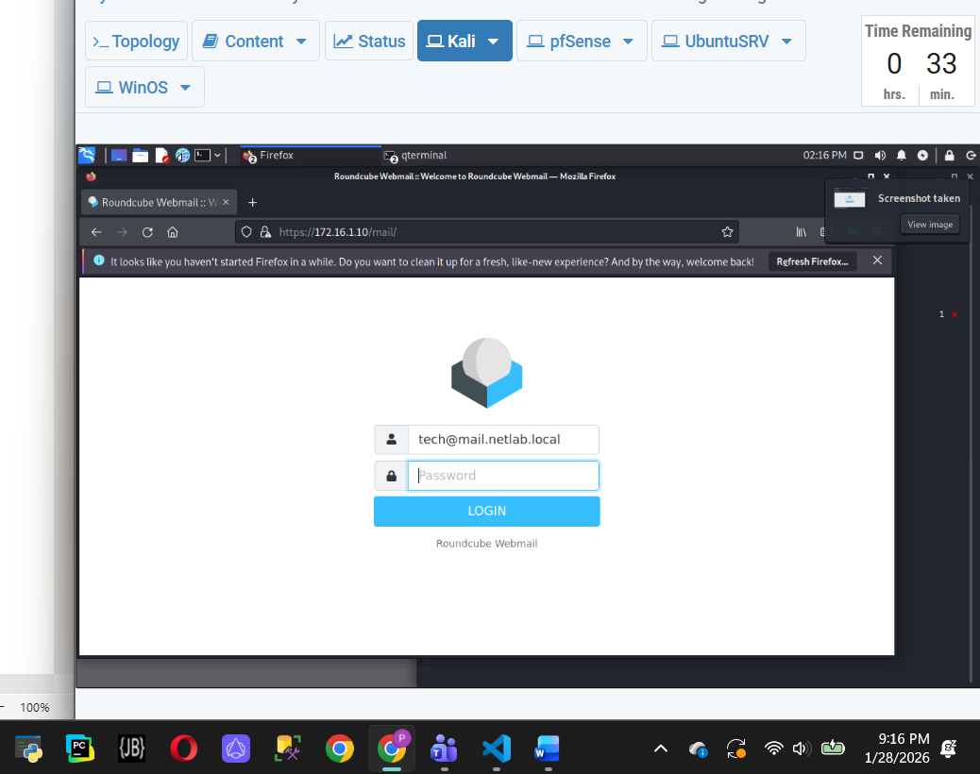
Screenshot 6: Fake Roundcube Webmail Login Page
This screenshot shows a fake Roundcube webmail login page opened in the Firefox browser on Kali Linux. The page is designed to closely resemble a legitimate email login portal in order to trick users into entering their credentials. This step demonstrates a common social engineering technique used to harvest usernames and passwords.
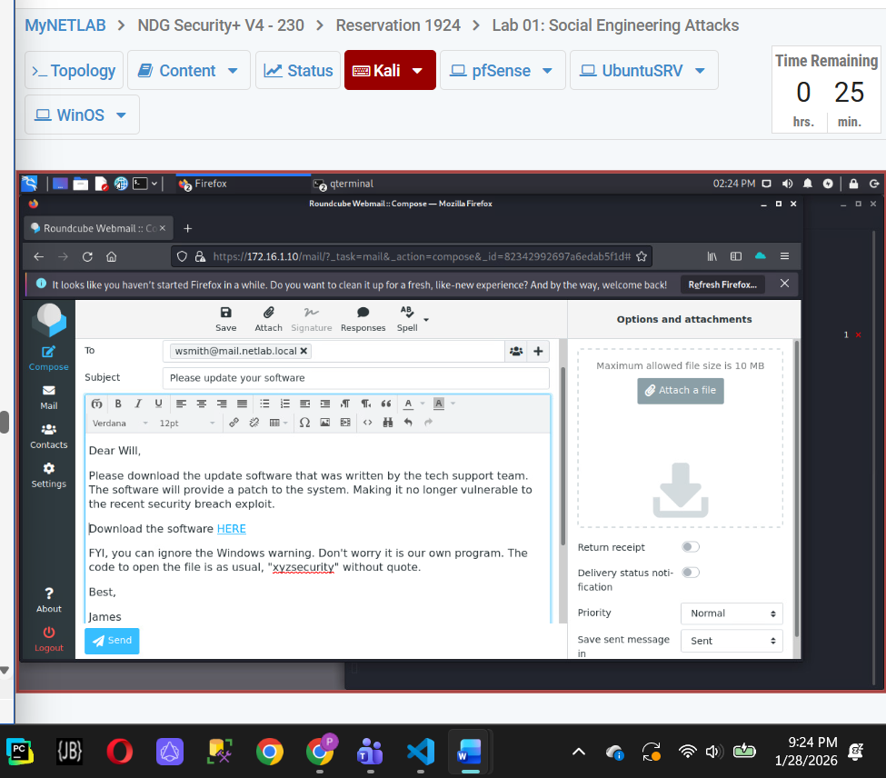
Screenshot 7: Phishing Email Used for Credential Harvesting
This screenshot shows a phishing email being composed within a webmail interface. The message is written to appear legitimate and instructs the recipient to install a software update, which is intended to deceive the user into taking action. This step demonstrates how attackers use persuasive email messages as part of a social engineering attack.
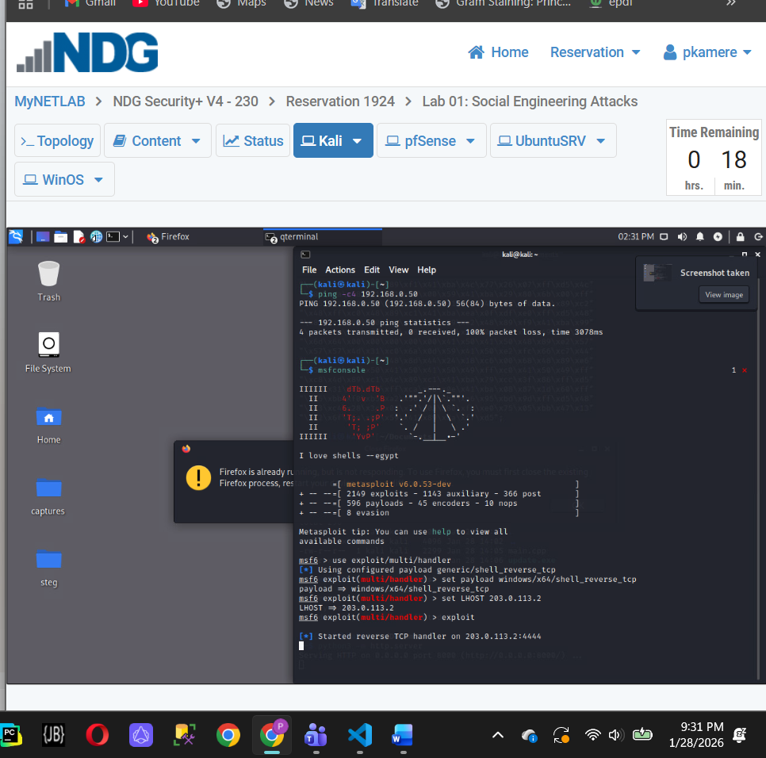
Screenshot 8: Metasploit Listener Receiving a Reverse Connection
This screenshot shows the Metasploit Framework running in the Kali Linux terminal with a reverse TCP handler active. The terminal output indicates that a connection has been received from the target system, confirming that the payload executed successfully. This demonstrates the effectiveness of the social engineering attack chain, from payload delivery to remote access.
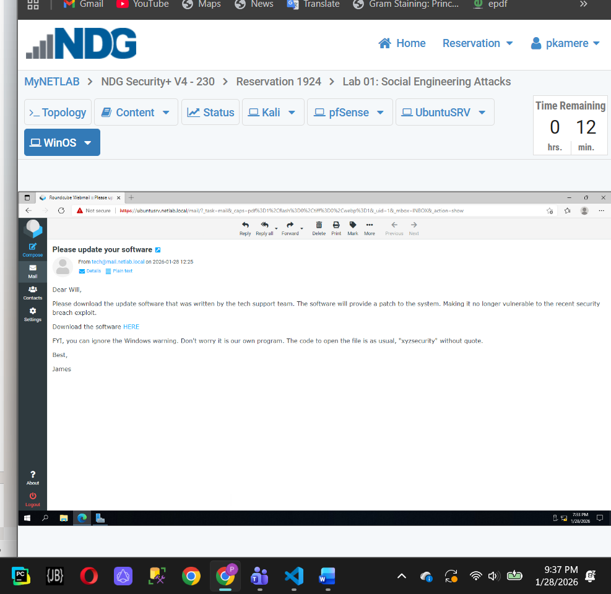
Screenshot 9: Phishing Email Received in User Inbox
This screenshot shows a phishing email received in the recipient’s inbox. The message appears to be a legitimate software update request and is designed to prompt the user to take immediate action.
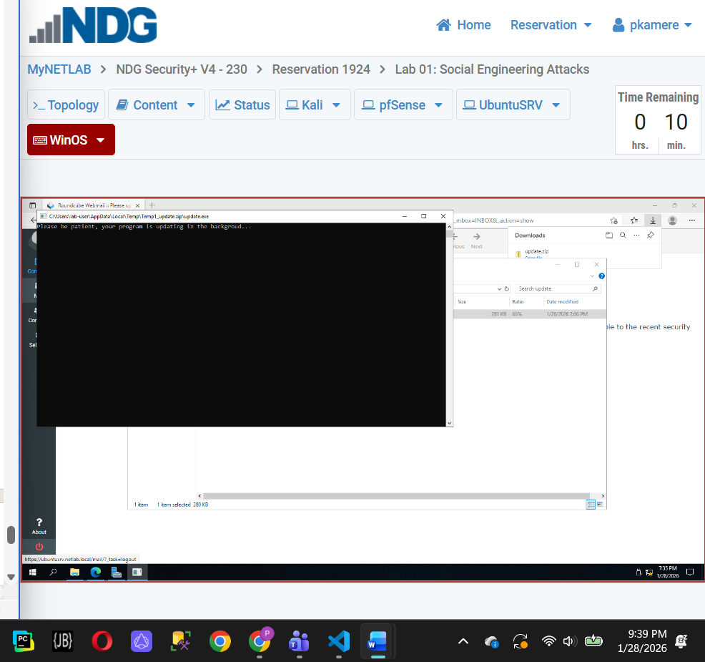
Screenshot 10: Executing the Downloaded File on the Target System
This screenshot shows the target Windows system with a command prompt window opened to run a downloaded executable file. The user executes the file from the command line, representing the moment when the recipient interacts with the content delivered through the phishing email. This step demonstrates how user action is required for a social engineering attack to progress beyond delivery.
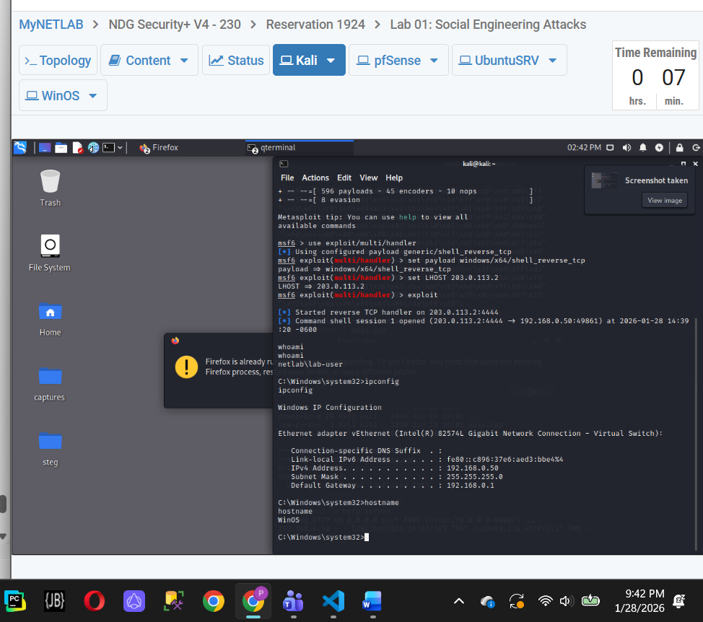

Conclusion: ·This lab demonstrated the key stages of a social engineering attack, including payload preparation, delivery through phishing, and attacker-side listener configuration. While the screenshots show successful setup and execution steps, they also highlight the importance of user interaction and proper network conditions for an attack to progress. Overall, the lab emphasizes how social engineering exploits trust and user behavior rather than relying solely on technical vulnerabilities.

